Magnetically Coupled Circuit - A Transformer

Experiment 1, 2 & 3

Justin Fortner

March 17th, 2018

Section 04 Wednesday 12:20-2:20

**Introduction**

The purpose of lab 5 is to investigate the properties of a transformer with a 1:1, 2:1 and 1:2 turn ratio. This includes voltage, current, impedance relationships and how ideal this transformer is. All of this is observed with both AC and DC power supplies.

Experiment 1 focuses on the behavior of a transformer in a DC power supply.

Experiment 2 focuses on focuses on the behavior of a transformer under different turn ratios.

Experiment 3 focuses on the impedance of the transformer.

**DC Behavior**

The following circuit in **Figure 1** must be used in order to complete experiment 1.

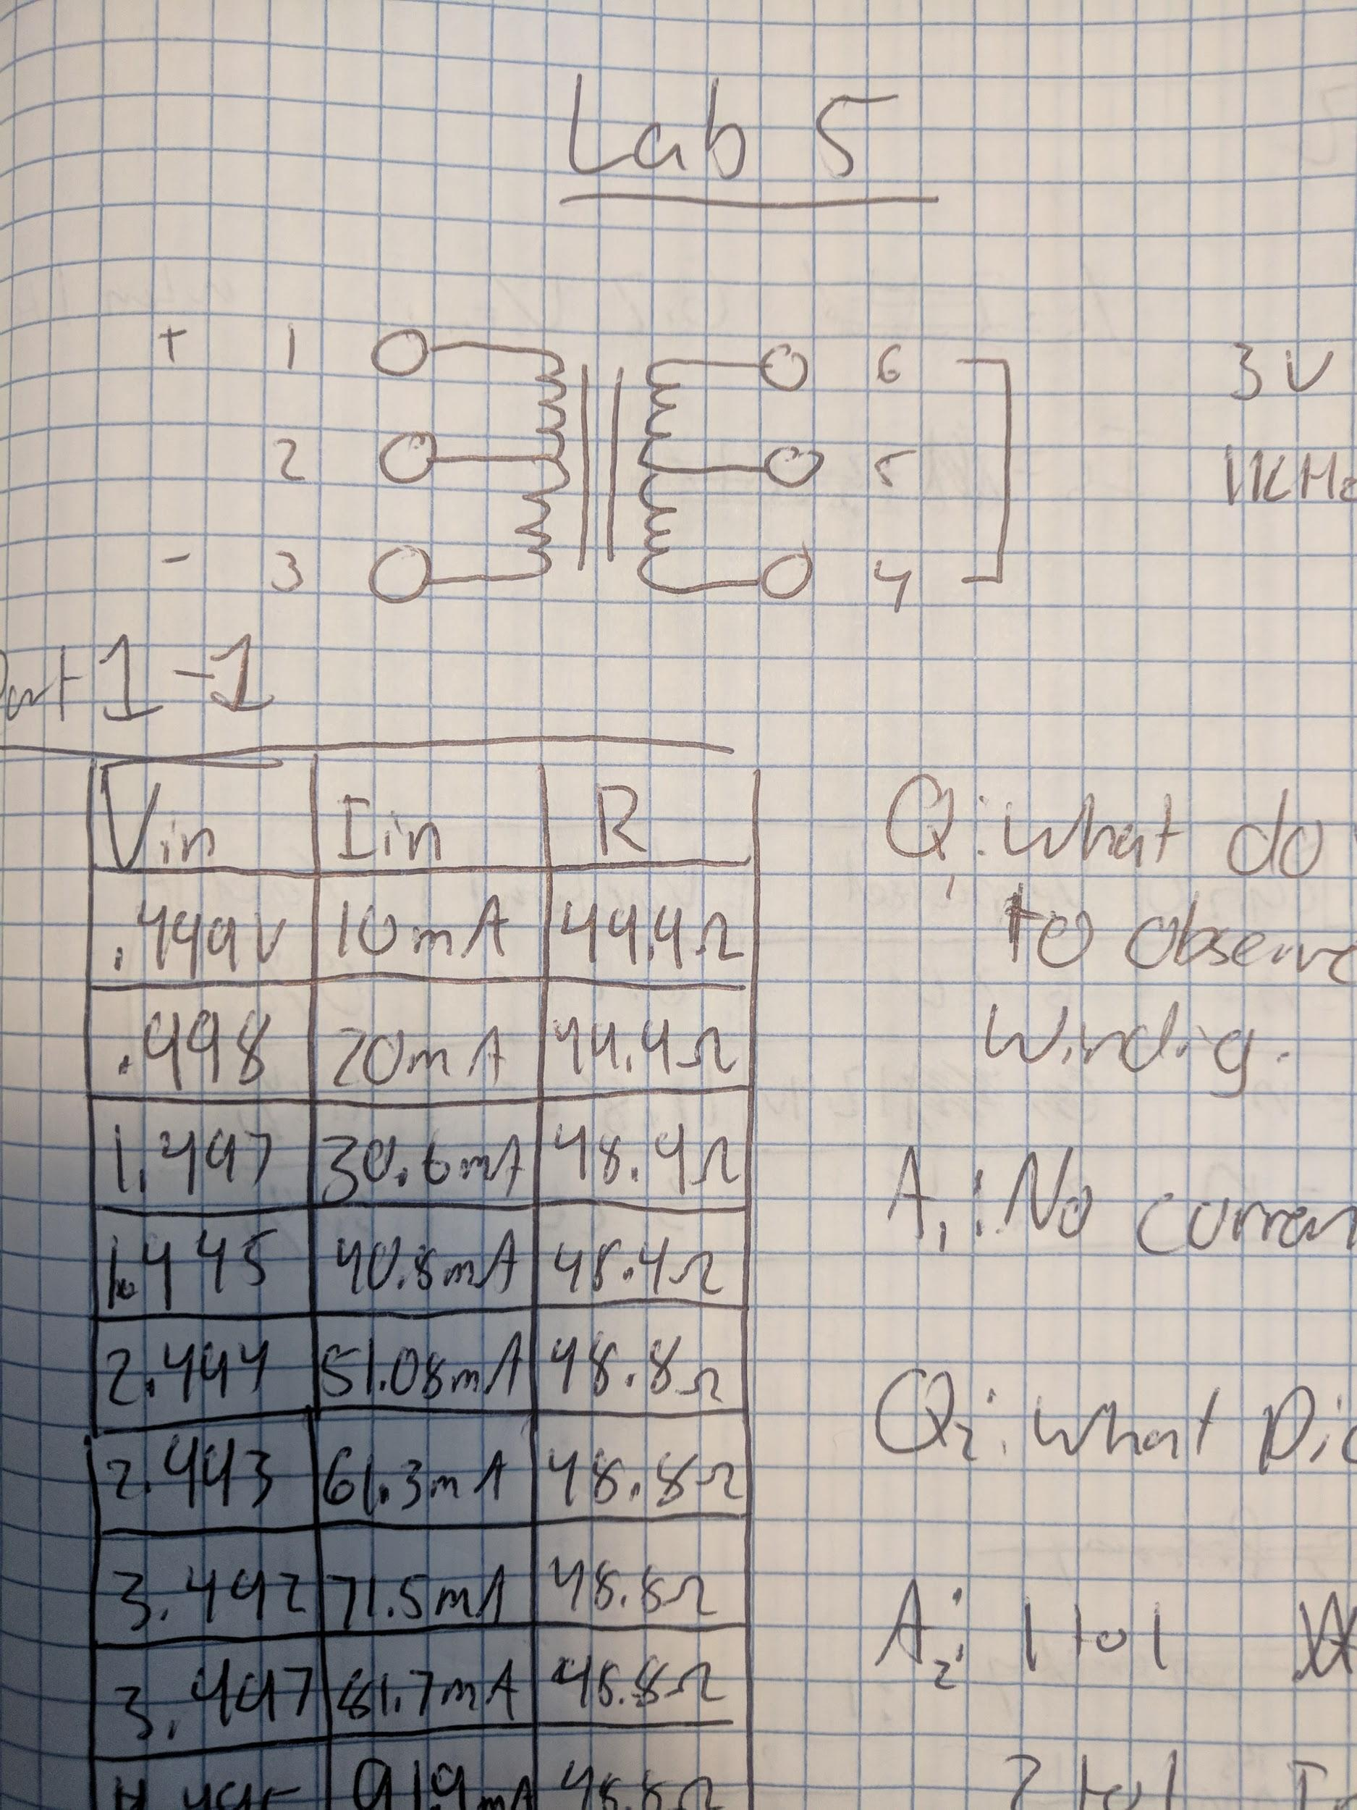

**Figure 1**

Transformer Circuit for Experiment 1, Lab 5

The left side of the transformer is used as the primary winding with the right side being the secondary winding. With the input into connection 1 on the primary winding, the secondary winding connected to 6 and 7, with the output from port 3 on the primary winding the turn ratio is 1:1. However for this experiment this does not matter as when an inductor is under DC current no current or voltage is observed on the secondary winding side. This can be observed in **Figure 2** below.

|  |  |  |  |  |
| --- | --- | --- | --- | --- |
| $V_{in}$ (V) | $V_{out}$ (V) | $I_{in}$ (mA) | $I_{out}$ (mA) | Impedence |
| .499 | 0 | 10 | 0 | 49.9 |
| .998 | 0 | 20 | 0 | 49.9 |
| 1.497 | 0 | 30.6 | 0 | 48.9 |
| 1.995 | 0 | 40.8 | 0 | 48.9 |
| 2.495 | 0 | 51.08 | 0 | 48.8 |
| 2.993 | 0 | 61.3 | 0 | 48.8 |
| 3.492 | 0 | 71.5 | 0 | 48.8 |
| 3.997 | 0 | 81.7 | 0 | 48.8 |
| 4.495 | 0 | 91.9 | 0 | 48.8 |
| 4.998 | 0 | 102.1 | 0 | 48.8 |

**Figure 2**

DC Behavior for Experiment 1, Lab 5

**Voltage and Turn Ratio**

For this experiment all three turn ratios must be observed. The same circuit as in **Figure 1** can be applied to this experiment. In order to obtain a 1:1 turn ratio primary winding must be 1-3 while the secondary winding must be 4-6. In order to obtain a 2:1 turn ratio primary winding must be 1-2 while the secondary winding must be 4-6. In order to obtain a 1:2 turn ratio primary winding must be 1-3 while the secondary winding must be 5-6. The voltage at each turn ratio must be observed and verified. The results can be seen in **Figure 3** below.

|  |  |  |  |  |
| --- | --- | --- | --- | --- |
| Turn Ratio | $V_{in}$ | $V_{out}$ (Expected) | $V_{out}$ (Experimental) | % Difference |
| 1:1 | 6.2 | 6.2 | 6.2 | 0% |
| 2:1 | 6.2 | 12.4 | 11.8 | 4.8% |
| 1:2 | 6.2 | 3.1 | 3.2 | 3.1% |

**Figure 3**

Voltage Observed for Experiment 2, Lab 5

As we can see, the output voltages follow the turn ratios. For a 1:1 the voltage passes equally. For a 2:1 the voltage is doubled in the secondary winding. For a 1:2 the voltage is halved in the secondary winding. The % differences observed can be attributed to the 50 $Ω$ resistor of the signal generator causing an unexpected voltage drop.

**Impedance Transformation**

The following circuit in **Figure 4** must be used in order to complete experiment 3.

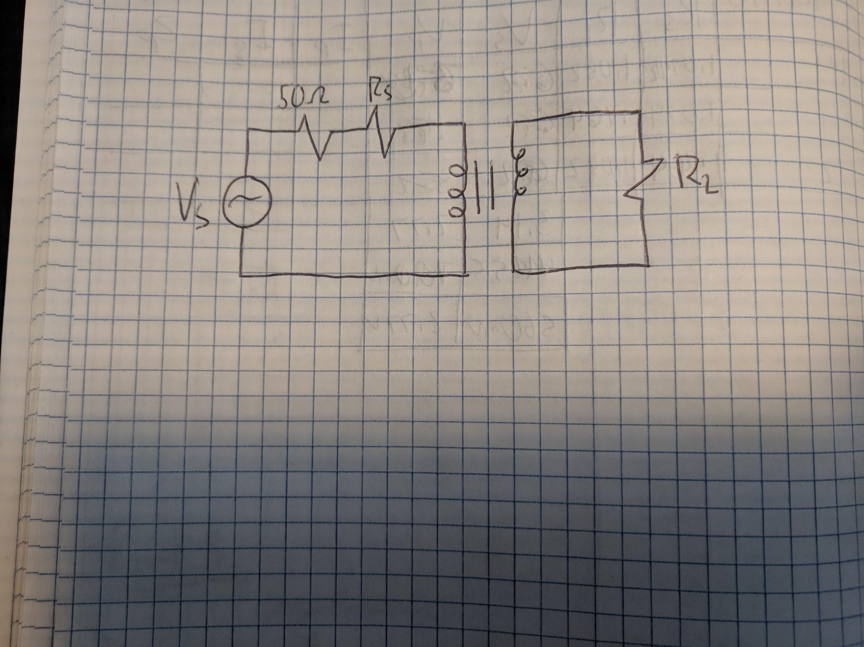

**Figure 4**

Transformer Circuit for Experiment 3, Lab 5

Three different circuits will be tested within this experiment in order to calculate the impedance. The primary impedance can be calculated using this equation: $Z_{p}=(N_{p}/N_{s})^{2}+Z_{s}.$ The resulting figures of these circuits can be seen in **Figure 5**.

|  |  |  |  |  |  |  |  |
| --- | --- | --- | --- | --- | --- | --- | --- |
| Turn Ratio | $R_{s}$ | $R_{L}$ | $V_{p}$ | $V_{s}$ | $I_{p}$ | $I_{s}$ | $Z_{p}$ |
| 1:1 | 1.079 $kΩ$ | 1.082 $kΩ$ | 2.77V | 3.14V | 2.43mA | 2.43mA | 50 |
| 2:1 | 1.079 $kΩ$ | .269 $kΩ$ | 111mV | 65.5mV | 98mA | 196mA | 200 |
| 1:2 | .269 $kΩ$ | 1.082 $kΩ$ | 280mV | 560mV | 1.04A | 520mA | 12.5 |

**Figure 5**

Impedance Circuit Observations for Experiment 3, Lab 5

The reason that the primary impedance can vary so greatly is that it is dependant on the turn ratio. This is seen in the equation: $Z_{p}=(N_{p}/N_{s})^{2}+Z_{s}$.

**Conclusion**

I learned a great deal about transformers in this lab. I had a very successful lab that allowed me to do so. I was able to complete all portions of this lab and understand the results that I was given. I can see how transformers can be extremely useful in real world applications. I also found it interesting how the transformer only reacted with an AC power source. I understand how turn ratios affect how a transformer performs. As well as how impedance affects a transformer. I was impressed by how ideal this transformer was.